VECTORS:
Graphically, a vector is represented by an arrow, defining the direction, and the length of the arrow defines the vector's magnitude. This is shown in Panel 1. . If we denote one end of the arrow by the origin O and the tip of the arrow by Q. Then the vector may be represented algebraically by OQ. 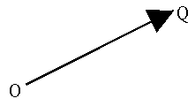
This is often simplified to just . The line and arrow above the Q are there to indicate that the symbol represents a vector. Another notation is boldface type as: Q.
The magnitude of a vector is denoted by absolute value signs around the vector symbol: magnitude of Q = |Q|.
1 EQUAL VECTORS: Two vectors, A and B are equal if they have the same magnitude and direction, regardless of whether they have the same initial points, as shown in
2 NEGATIVE VECTORS A vector having the same magnitude as A but in the opposite direction to A is denoted by –A
vector addition
We can now define vector addition. The sum of two vectors, A and B, is a vector C, which is obtained by placing the initial point of B on the final point of A, and then drawing a line from the initial point of A to the final point of B , as illustrated in Panel 4. This is sometines referred to as the "Tip-to-Tail" method. 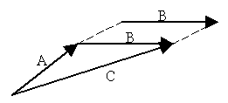
The operation of vector addition as described here can be written as C = A + B
Vector subtraction is defined in the following way. The difference of two vectors, A - B , is a vector C that is, C = A - B
or C = A + (-B).Thus vector subtraction can be represented as a vector addition.

The Parallelogram Law
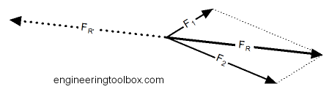
The procedure of "the parallelogram of vectors addition method" is
- draw vector 1 using appropriate scale and in the direction of its action
- from the tail of vector 1 draw vector 2 using the same scale in the direction of its action
- complete the parallelogram by using vector 1 and 2 as sides of the parallelogram
- the resulting vector is represented in both magnitude and direction by the diagonal of the parallelogram

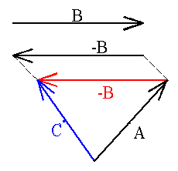
Multiplication of vectors with scalars
Any quantity which has a magnitude but no direction associated with it is called a "scalar". For example, speed, mass and temperature.
The product of a scalar, m say, times a vector A , is another vector, B, where B has the same direction as A but the magnitude is changed, that is,
|B| = m|A|.

Components of Vectors
The vector A can be represented algebraically by A = A_{x} + A_{y}. Where A_{x} and A_{y} are vectors in the x and y directions. If A_{x} and A_{y} are the magnitudes of A_{x} and A_{y}, then A_{x} and A_{y} are the vector components of A in the x and y directions respectively.
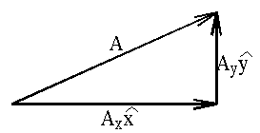
The breaking up of a vector into it's component parts is known as resolving a vector.
The breaking up of a vector into it's components, makes the determination of the length of the vector quite simple and straight forward.
Since A = A_{x} + A_{y} then using Pythagorus' Theorem
The resolution of a vector into it's components can be used in the addition and subtraction of vectors.
To illustrate this let us consider an example, what is the sum of the following three vectors?
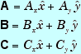
By resolving each of these three vectors into their components we see that the result is .  D_{x} = A_{x} + B_{x} + C_{x}  D_{y} = A_{y} + B_{y} + C_{y} | 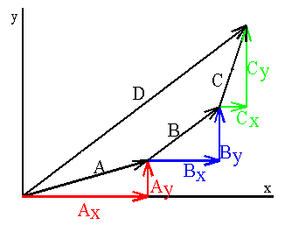
From elementary trigonometry we have, that cosθ = A_{x}/|A| therefore A_{x} = |A| cos θ, and similarly
A_{y} = |A| cos(90 - θ) = |A| sinθ. 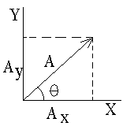
Product of Vectors
The multiplication of two vectors, is not uniquely defined, in the sense that there is a question as to whether the product will be a vector or not. For this reason there are two types of vector multiplication.
First, the scalar or dot product of two vectors, which results in a scalar.
And secondly, the vector or cross product of two vectors, which results in a vector.
The scalar product of two vectors, A and B denoted by A·B, is defined as the product of the magnitudes of the vectors times the cosine of the angle between them
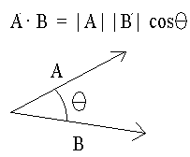
CROSS PRODUCT
The symbol used to represent this operation is a large diagonal cross (×), which is where the name "cross product" comes from. Since this product has magnitude and direction, it is also known as the vector product.
A × B = AB sin θ

