**Topics: Energy and work done, Thermal physics**

Choose the correct answer:

1. Which represents the main energy changes that take place in a coal-fired power station?

A chemical → heat → kinetic → electrical

B chemical → heat → light → electrical

C chemical → kinetic → electrical → potential

D kinetic → heat → light → electrical

2. Which object converts sound energy into electrical energy?

**A** electric bell

**B** loudspeaker

**C** microphone

**D** radio

3. A tidal power station is made by building a barrage across the mouth of a river. At high tide the sea water is trapped behind the barrage.

The diagram shows water stored behind a dam.



The water flows to a turbine and turns a generator.

Which sequence for the conversion of energy is correct?

A gravitational energy → kinetic energy → electrical energy

B kinetic energy → gravitational energy → electrical energy

C gravitational energy → electrical energy → kinetic energy

D kinetic energy → electrical energy → gravitational energy

4.



5. Which process in the Sun produces energy?

A burning

B nuclear fission

C nuclear fusion

D radiation

6. A parachutist has opened his parachute and is falling to Earth at constant speed.

What is the principal energy conversion taking place as he falls?

A kinetic energy → potential energy

B kinetic energy → thermal energy (heat)

C potential energy → kinetic energy

D potential energy → thermal energy (heat)

7. Which of the following is NOT a form of energy

A gravity

B light

C kinetic

D nuclear

8. The unit of energy is

A J

B kg

C N

D W

9. Which of the following statement about liquid is incorrect?

A It takes the shape of the container

B Volume is not fixed

C it can flow

D Molecules are slightly further apart than in solids

10. Which of the following is correct about gas?

A Has fixed shaped

B Volume is fixed

C it cannot flow

D Particles move about freely at high speed.

ANSWER THE FOLLOWING:

1. Define the following:

1. Energy
2. Work done
3. Renewable energy resources
4. Kinetic energy
5. Non renewable energy
6. Potential energy

2. A ball of mass 0.5 kg has 100 J of kinetic energy. What is the speed of the ball?

3. How much work is done if a force of 12 N moves an object a distance of 5m?

4. Fill in the blanks using the words given below. Each word can also be used more than once..

**heat, light, sound, kinetic**

1. In a vacuum cleaner, electrical energy is transferred into mainly _______________ energy and unwanted ________________ energy.
2. In a torch, electrical energy is mainly transferred into mainly ______________ and ___________________ energy.
3. In an iron, electrical energy is transferred into mainly ______________ energy.

5.

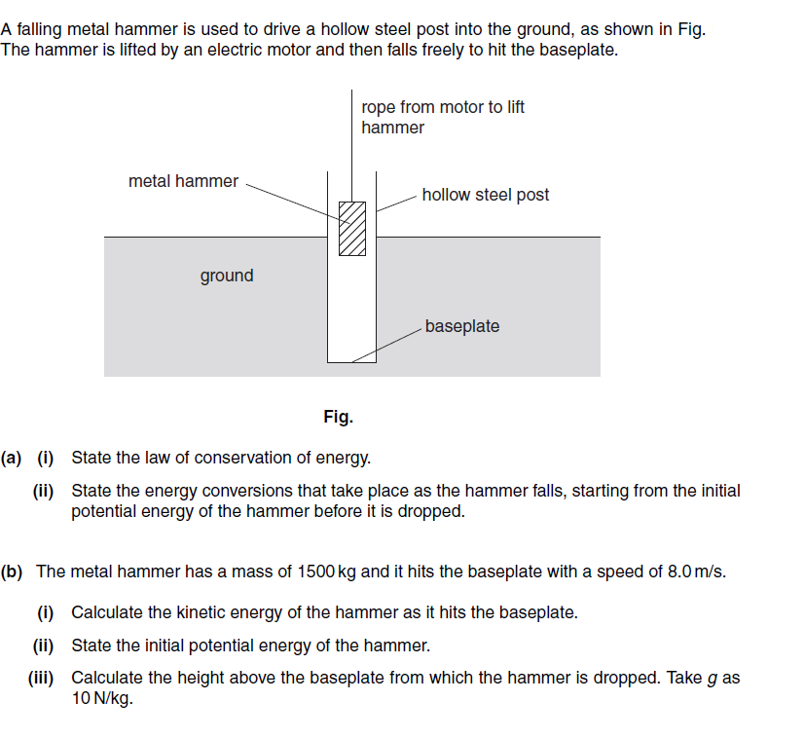

6. Match the following:

1. Chemical energy - energy transferred from hot object to cold object
2. Electrical energy - energy of an object due to its motion
3. Gravitational potential energy – energy released in a substance when a

chemical reaction takes place

1. Heat energy – energy released when the nucleus of an atom splits
2. Kinetic energy – energy transferred by an electric current
3. Nuclear energy – energy of an object due to its position.

7.

8. Look at the picture and answer the following:

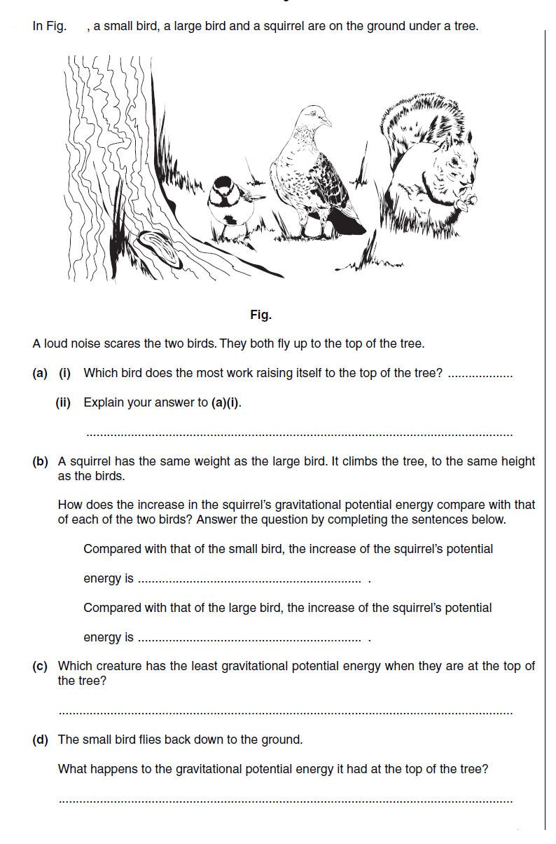

9. A 20 N weight is raised throgh a height of 0.4m. Calculate a)Work done b) the gain of potential energy of the object.

10. An object of mass 6 kg has a speed of 5m/s.

a) what is its kinetic energy?

b) What is its kinetic energy if its speed is doubled.