**TOPIC: 11**

**ATOMS AND RADIOACTIVITY**

**11.01- 11.03 The Nuclear Atom**

**Objectives:**

By the end of this chapter you should be able to:

* Describe the structure of an atom in terms of a nucleus and electrons.
* Describe how the scattering of α-particles by thin metal foils provides evidence for the nuclear atom.
* Describe the composition of the nucleus in terms of protons and neutrons.
* Use the term proton number Z
* Use the term nucleon number A
* Use the term nuclide and use the nuclide notation AXZ
* Use the term isotope
* Give and explain examples of practical applications of isotopes

**Content**

All matter is made up of atoms. An atom is like a tiny solar system. In the center of the atom is the nucleus which is a cluster of protons and neutrons. The protons have a positive electric charge while the neutrons are electrically neutral. The nucleus makes up almost all of an atom's mass or weight. Whirling at fantastic speeds around the nucleus are smaller and lighter particles called electrons which have a negative electric charge.  
  
An atom has the same number of electrons (- ve charge) and protons (+ ve charge) to make the atom electrically neutral. An extremely powerful force, called the nuclear force, holds the protons together in the nucleus as they naturally repelled one another electrically.

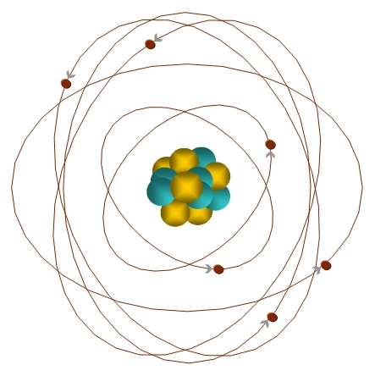

**Discovery of the nucleus**

Rutherford fired Helium nuclei at a piece of gold foil which was only a few atoms thick.

He found that while most of the helium nuclei passed through the foil, a small number were deflected and, to their surprise, some helium nuclei bounced straight back.although most of them passed through. (About 1 in 10,000 hit)

Rutherford’s new evidence allowed him to propose a more detailed model with a **central nucleus**.

He suggested that the **positive charge** was all in a central nucleus. With this holding the electrons in place by electrical attraction

Bohr refined Rutherford's idea by adding that the electrons were in **orbits**.

**Electron shells**

Electrons are arranged in shells or orbits around the nucleus.

**Maximum number**

There is a definite arrangement of the electrons in these shells and a maximum number of electrons possible in each shell.

|  |  |  |  |  |  |
| --- | --- | --- | --- | --- | --- |
| **Shell or Orbit Number** | 1 | 2 | 3 | 4 | 5 |
| **Maximum Number of Electrons** | 2 | 8 | 18 | 32 | 50 |

The most electrons possible in the first shell are 2. After the first shell is filled, the second shell starts filling up, according to the number of positive charges in the nucleus. The most allowed in the second shell is 8 electrons. Then the third shell starts to fill.

**Nuclide:** A type of atom or nucleus with a specific number of protons and neutrons.

**Nuclide Notation:**  A method of representing an element and the number of its subatomic particles



**Atomic number (Z)**

- gives position on the Periodic Table

- equals the number of protons in the nucleus

**Mass number (A)**

- equals the number of protons and neutrons in the nucleus

**Isotopes:**

Isotopes are atoms of the same element which differ in the number of neutrons they contain. For example, helium-3 (3He), with two protons and one neutron in each nucleus, and helium-4 (4He), with two protons and two neutrons, are two different isotopes of helium. Nearly all elements found in nature are mixtures of several different isotopes. Although the chemical properties of isotopes of the same element are the same, the physical properties differ. The natural proportions of the isotopes are expressed in the form of an abundance ratio.

**Uses of Isotopes:**

## Agricultural Applications - radioactive tracers: Radioisotopes can be used to help understand chemical and biological processes in plants.

## Archaeological Dating:

**Radioactivity:**

Atomic nuclei that are not stable, tend to approach stable configuration(s), by the process of radioactivity.  Atoms are radioactive because the ratio of neutrons to protons is not ideal. **Through radioactive decay, the nucleus approaches a more stable neutron to proton ratio**. Radioactive decay releases different types of energetic emissions. The three most common types of radioactive emissions are alpha particles, beta particles, and gamma rays.

* 1. Alpha particles (α)
  2. Beta particles (β)
  3. Gamma-rays (γ)

## Alpha (http://library.thinkquest.org/17940/texts/images/alpha.gif) Decay:

Alpha decay occurs when the nucleus spontaneously ejects an http://library.thinkquest.org/17940/texts/images/alpha.gifparticle. An http://library.thinkquest.org/17940/texts/images/alpha.gifparticle is really 2 protons and 2 neutrons, or an He nucleus. So when an atom undergoes http://library.thinkquest.org/17940/texts/images/alpha.gifdecay, its atomic number decreases by 2 and its atomic mass decreases by 4. http://library.thinkquest.org/17940/texts/images/alpha.gifparticles do not penetrate much material, for they can be stopped by paper. An example of http://library.thinkquest.org/17940/texts/images/alpha.gifdecay is the following:

Pu239 ->U235 + http://library.thinkquest.org/17940/texts/images/alpha.gifparticle (He-4 nucleus)

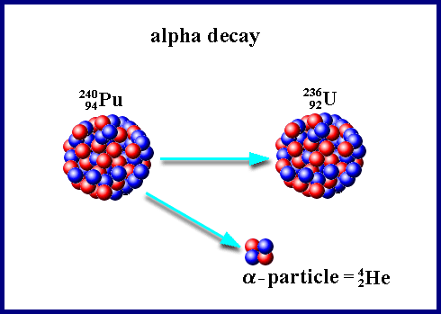

## Beta (ß)- Decay:

An excess of neutrons in an atom's nucleus will make it unstable, and a neutron is converted into a proton to change this ratio. During this process, a ß particle is released, and it has the same mass and charge as an electron. So the ß particle is accompanied by virtually mass less and charge less particles called neutrinos, whose kinetic energy makes up for the energy difference still remaining. As a result of ß- decay, the atomic number of the atom increases by 1.

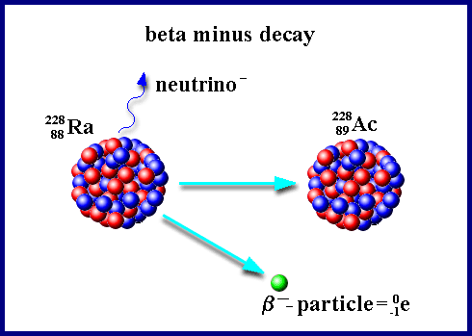

## Gamma Radiation:

Gamma ray emission usually occurs with http://library.thinkquest.org/17940/texts/images/alpha.gifand ß emission. Gamma rays have no charge or mass, so their emission doesn't change the chemical composition of the atom. Instead, it results in a loss of radiant energy. Gamma ray emission occurs because the nucleus is often unstable after http://library.thinkquest.org/17940/texts/images/alpha.gifand ß decay. There are cases where pure gamma emission occurs, and this is where an isotope exists in two forms (nuclear isomers). They have the same atomic and mass numbers, but have different nuclear-energy content. So gamma emission occurs when the isomer goes from a higher to a lower energy form. The isotope protactinium-234 exists in two different energy states, and it emits gamma rays when undergoing transition to the lower-energy state.

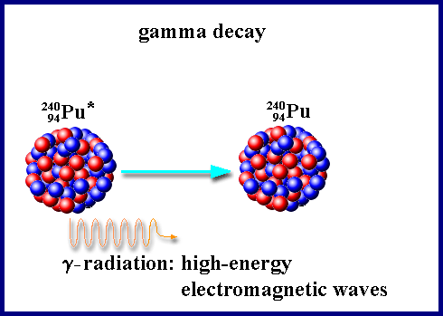

## Half Life:

Physicists have discovered that the number of nuclei decays on a time unit is proportional to the number of all nuclei in the sample. The quantity of the number of decays in the period of time in which they proceeded is called the activity of the radioactive source:

A =N/t        (1)

The unit for *A* is *becquerel* (1 Bq). The source has the activity of one becquerel, if during each second one nucleus decays.

A sample of a radioactive substance will decay into various particles. The rate of decay is measured by how long it takes for half the sample to decay. The decay of an individual atom is totally random, but for a large sample size, we can get a good prediction of the half life.

Half life is also defined as the time interval for the activity of a specimen to fall to half of its original value.



**Geiger–Müller Tube:**

A Geiger–Müller tube consists of a tube filled with a low-pressure (~0.1 Atm) inert gas such as helium, neon or argon (usually neon. The tube contains electrodes, between which there is a potential difference of several hundred volts, but no current flowing. The walls of the tube are either entirely metal or have their inside surface coated with a conductor to form the cathode while the anode is a wire passing up the center of the tube.

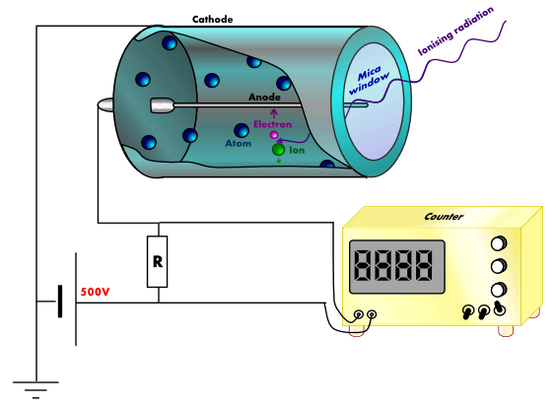

When ionizing radiation passes through the tube, some of the gas molecules are ionized, creating positively charged ions, and electrons. The strong electric field created by the tube's electrodes accelerates the ions towards the cathode and the electrons towards the anode. The ion pairs gain sufficient energy to ionize further gas molecules through collisions on the way, creating an avalanche of charged particles.

This results in a short, intense pulse of current which passes (or *cascades*) from the negative electrode to the positive electrode and is measured or counted. Most detectors include an audio amplifier that produce an audible click on discharge.



