GRADE 8 Magnets and Magnetism

Only certain metals, for example iron and nickel, may be magnetized. The metal to be magnetized if full of tiny magnets, every one one which has a north - red – pole and blue – south – pole as shown below. Normally these magnets or oriented randomly - below left:
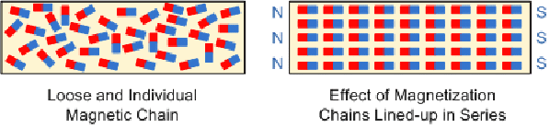
If the metal is magnetized as in the diagram above right these tiny magnets line up as to produce a net magnetic field as shown below.
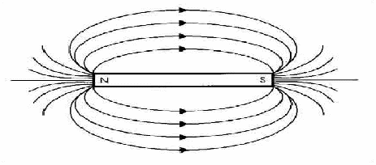
The diagram above shows that magnetic fields are directed from north to south poles.

The phrase “opposites attract” is derived from the law of magnetism which says that magnetic poles of opposite polarity attract each other, so north and south poles are attracted towards each other. In contrast, like poles repel each other. The “Opposites Attract, Like Repel” law can be simply illustrated by showing the magnetic field between poles of different polarities.
