Grade 7 Energy- Work- Conservation of Energy

Use the following diagram to answer the following questions .Neglect the air resistance.
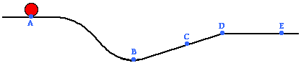
- As the object moves from point A to point D across the surface, the sum of its gravitational potential and kinetic energies ____.
- Decreases, only b) decreases and then increases c) increases and then decreases d) remains the same.

- The object will have a minimum gravitational potential energy at point ____.
- A b) B c) C d) D e) E

- The object's kinetic energy at point C is less than its kinetic energy at point ____.
- A only b) A, D and E c) B only d) D and E

- A cart is loaded with a brick and pulled at constant speed along an inclined plane to the height of a seat-top. If the mass of the loaded cart is 3.0 kg and the height of the seat top is 0.45 meters, then what is the potential energy of the loaded cart at the height of the seat-top?
